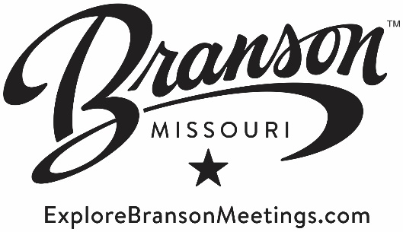
Meeting & Convention Committee Meeting
February 15, 2017
Chair: Jay Wilson
Agenda

Welcome

Public Comment

2016 M&C Research

4Q 2016 and EOY Results

Marketing, Advertising & Social Media

Tradeshows & Sponsorships

2017 Plans

