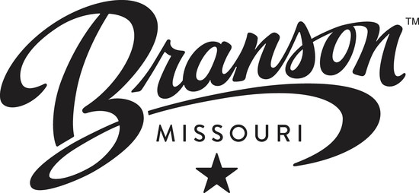

M&C Committee Meeting
Branson Convention Center
Roark Creek Room
July 21, 2016
2 pm
Agenda

Committee Chair: Marc Mulherin

Icebreaker Activity

Public Comments

Quick CVB News

Sales Reports

Site Inspections

Marketing

Recent/Upcoming Travel

Public Comments/Announcements

