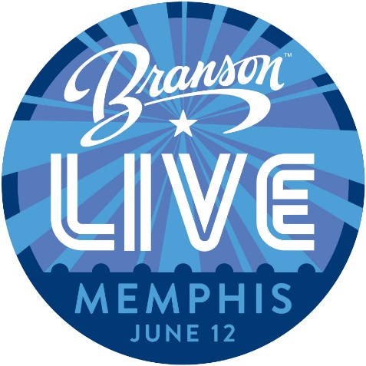
Branson Live in Memphis Task Force Meeting
Thursday, February 8, 2018
Task Force Members
Becky Jewsbury | Westgate Resorts | Julie Wilson | The Track Family Fun Parks
Mike Pitman | Sight & Sound Theatres | Joey Thorsen | Silver Dollar City Attractions
CVB Staff in Attendance: Leah Chandler, Lenni Neimeyer, Deborah Cohen, Julie Peters, Courtney Bressler
Task Force Members not in attendance: Kelly Holman from Hilton of Branson and Kristy Adams from The Mansion Theatre
- Leah reminded the task force that the event was revised to be a day event to bring down the cost and hopes to be able to bring back the evening component next year if possible.
- The event is June 12 at the Guest House at Graceland. Lenni passed out the preliminary itinerary and noted that it would be best to arrive the night before the event to set up.
- Leah wanted feedback on which size tables, the group decided on six foot tables, which Deborah will follow up on.
- Lenni noted that when guests arrive they will receive name tags and a ‘passport’ to bring to each booth to be stamped.
- Leah noted that the 2018 What’s New Video will be shown and Million Dollar Quartet will be preforming at the event. Leah noted that an air wall will be set up to help with sound. The event is from 10:00 am -2:00 pm., people will arrive around 9:30 am. and clean-up will begin around 2:15 pm. Lunch will be provided with the Million Dollar Quartet performance to follow. Leah noted that the bulk of guests will be leisure groups, meeting planners, and a few travel journalists.
- Lenni noted she and Julie are reaching out to about 500 identified group and military reunion planners in the area.
- Lenni noted that April 6, 2018 is the final due date for the partnership form. There is a limit of 25 spots available and currently 10 are signed up.
- Leah asked the task force if they were missing an opportunity to contact and meet up with more tour operators on Tuesday evening as a dinner. Deborah suggested calling a couple restaurants in the area and reserving the guest room. The task force loved the idea and decided to pick a few restaurants with group space to give as an open invitation to guests to explore Memphis on their own. Deborah and Joey will look into the restaurants to find a few to reserve rooms for the evening. Julie suggested only offering dinner to the guests who contact back to say they cannot attend the daytime event, so attention is not taken away from the daytime event.
- Lenni suggested possibly arriving a day early and get up early Monday morning to make personal sales calls for the event. Leah suggested that when giving out the itinerary to offer businesses to arrive a day early and make sales calls on Monday, to leave a day later and make sales calls on Wednesday, or do sales calls both Monday and Wednesday.
- Lenni noted the task force needed to come up with a grand prize and raffle prizes. Leah suggested each business bringing their own gift for the raffle. Leah asked for suggestions for a gift for each guest. The task force decided on looking into cutting boards with the Branson, MO logo engraved on it.

The next Branson Live in Memphis Task Force Meeting will be on March 5th or 6th. Once a finalized date it set Leah will send the committee an email.

